AGROSENSE LTD.
Modular Assignment 5 | Network and IoT Solution
Md Habib Ahmed | Amity University Online | October 2026

1. Objective and scope
AgroSense Ltd. requires secure, cloud-hosted monitoring of soil moisture, temperature and humidity across farms. This prototype simulates three farms using one Python logical gateway, ingests MQTT telemetry through AWS IoT Core (Stockholm, eu-north-1), stores readings in Amazon DynamoDB, and visualizes live messages in Grafana. Power BI provides complementary analysis of exported CSV/JSON data. Physical sensors and production-scale deployment were outside the test scope.

2. Network architecture and data flow
The simulator publishes to agrosense/farm1/telemetry, agrosense/farm2/telemetry and agrosense/farm3/telemetry using MQTT over TLS (port 8883) with an X.509 client certificate. AWS IoT Core acts as the managed MQTT broker. The rule AgroSense_Sensor_Data_Rule matches agrosense/+/telemetry and forwards payloads to DynamoDB through its authorized service role. Grafana subscribes directly to AWS IoT Core using a separate client certificate. The logical gateway represents three simulated farms, not three individually registered physical devices.

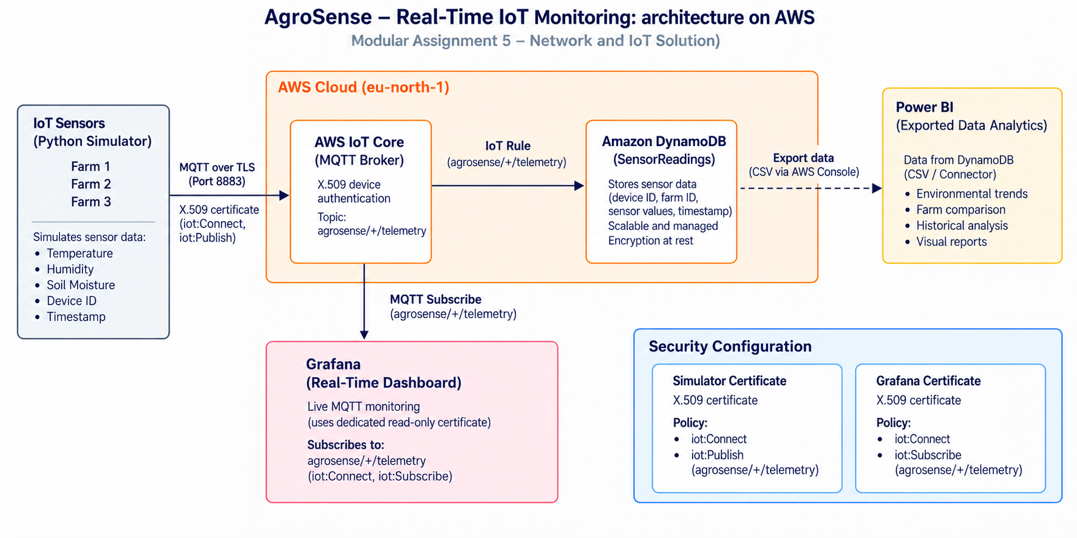

3. IoT configuration and database integration
The registered Thing AgroSense-Farm1-Sensor01 authenticates using a certificate and a publish-only IoT policy. The Python AWS IoT SDK simulator sent five samples per farm (15 per run) with MQTT QoS 1 acknowledgements. The DynamoDBv2 rule action writes to AgroSense-SensorReadings with device_id (string) as partition key and timestamp (number) as sort key. Console inspection verified multi-farm records; a separate filtered scan later confirmed all 100 load-test records.

4. Datasets and visualization
Two student-created datasets support analysis: sensor_readings.csv (15 readings containing farm/device identifiers, soil moisture, temperature and humidity) and monitoring_logs.json (15 MQTT publish records with timestamps, status and publish_ack_latency_ms). The observed average publisher acknowledgement latency was 15.46 ms; this is not end-to-end database latency. Power BI displays average environmental values by farm, sample and farm counts, publish status, and average acknowledgement latency. Grafana receives live MQTT updates, including load_test messages, while its subscriber is connected. The supporting dashboard screenshots are submitted separately.

5. Security and scalability
MQTT traffic uses TLS and X.509 mutual authentication. Separate IoT certificate identities and policies isolate the simulator (Connect/Publish) from Grafana (Connect/Subscribe); the simulator policy was tightened and publishing was retested successfully. The AWS IoT rule uses an IAM role for DynamoDB writes. DynamoDB provides managed scaling and encryption at rest. Certificate private keys and credentials are excluded from shared documentation and GitHub. For production, review exact IAM resource scopes, key rotation, device-specific identities, and monitoring.
A five-worker AWS IoT Data Plane API test submitted 100 messages in 1.17 seconds (approximately 85.5 publish calls/second). A filtered DynamoDB scan found 100 matching load-test items among 227 scanned records; Grafana also displayed load_test telemetry. This verifies short-run ingestion, not maximum throughput, sustained capacity, or end-to-end latency. The load test used the IoT Data Plane API, whereas the regular simulator used MQTT over TLS.

6. Development strategy and cost considerations
The implementation sequence was: define farm telemetry and topics; provision AWS IoT identities and scoped policies; run the simulator; configure the IoT rule and DynamoDB; connect Grafana and prepare Power BI datasets; validate ingestion, security and load behavior. Managed IoT Core and DynamoDB reduce infrastructure maintenance and permit gradual scaling. Cost depends on messages, rule executions, storage and monitoring; no verified billed-cost amount was captured. A separate 1–2 page strategy document expands on deployment choices, scalability, security and cost controls.

7. Results, limitations and reproducibility
The prototype demonstrated secure MQTT publishing, cloud database storage and retrieval, live Grafana subscription, and Power BI analysis of both datasets. Evidence is provided as separately uploaded, numbered screenshots of device registration, MQTT tests, DynamoDB records, dashboards, certificate/policy settings and the 100-message test. Limitations include simulated devices, a shared logical gateway identity, import-based Power BI, and a small API-based load test. Source code, datasets, sanitized configuration examples and the architecture diagram belong in the GitHub repository.
GitHub:

